UML Assignment

**Assignment 1:**

Draw UML Class Diagram and Sequence Diagram for the following Program:

import java.util.Scanner;

public class JavaExample {

public static void main(String[] args) {

double num1, num2;

Scanner scanner = new Scanner(System.in);

System.out.print("Enter first number:");

/* We are using data type double so that user

* can enter integer as well as floating point

* value

*/

num1 = scanner.nextDouble();

System.out.print("Enter second number:");

num2 = scanner.nextDouble();

System.out.print("Enter an operator (+, -, *, /): ");

char operator = scanner.next().charAt(0);

scanner.close();

double output;

switch(operator)

{

case '+':

output = num1 + num2;

break;

case '-':

output = num1 - num2;

break;

case '*':

output = num1 * num2;

break;

case '/':

output = num1 / num2;

break;

/* If user enters any other operator or char apart from

* +, -, * and /, then display an error message to user

*

*/

default:

System.out.printf("You have entered wrong operator");

return;

}

System.out.println(num1+" "+operator+" "+num2+": "+output); }

**Class Diagram**

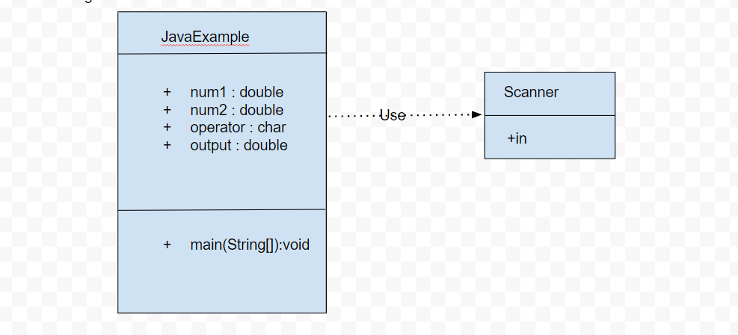

**Sequence Diagram**

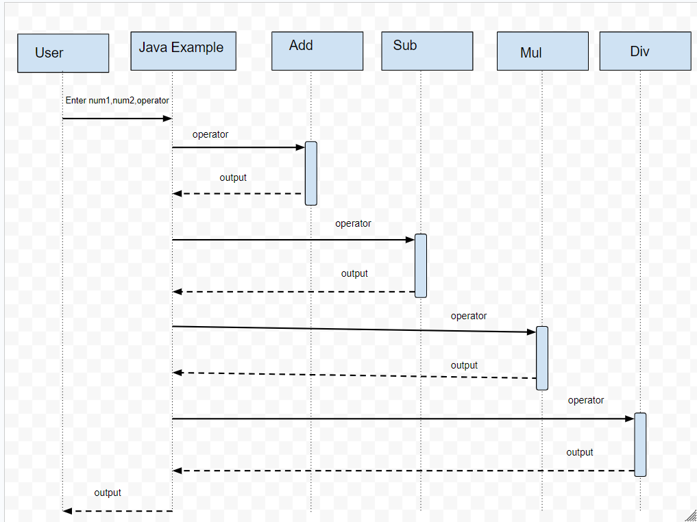

**Assignment 2**:

Draw UML Class Diagram and Sequence Diagram for an Access Control Entry system.

Eg. When there is a visitor an our office the security will follow some steps to check whether the visitor should be allowed to enter or not.

**Class Diagram**

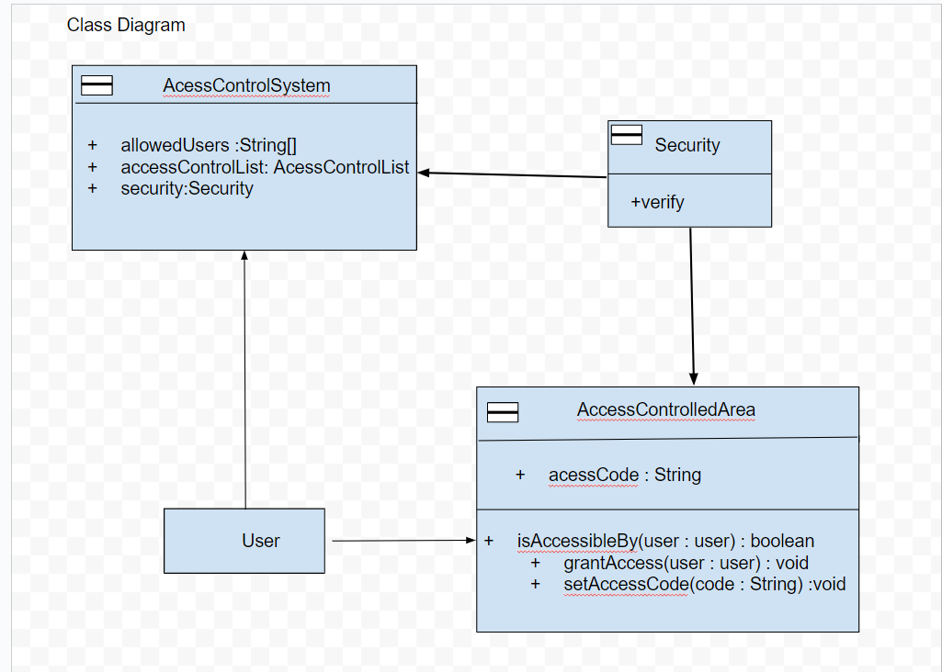

**Sequence Diagram**

